Priority Queue

Goal: Can write and use a heap implementation of a priority queue.

Problem Description

In this assignment, you will create a generic heap class and use it to implement a priority queue.

## Driver Class

Create a driver class to test your priority queue.

## Heap Class

Use the following UML to create a Heap Class.

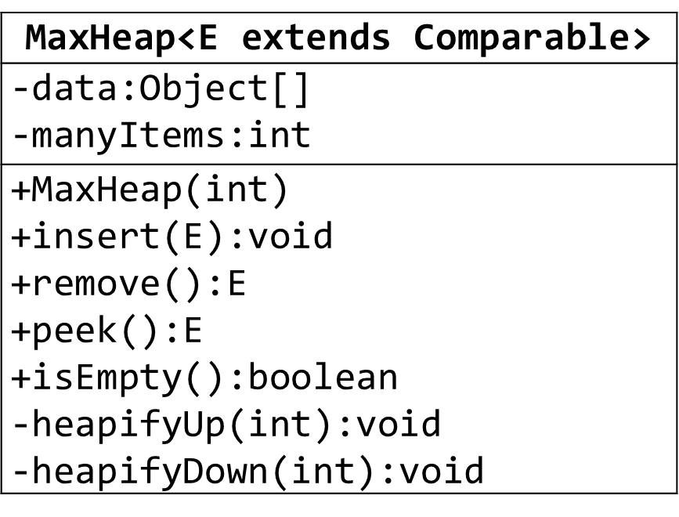

## Priority Queue Class

Use the following UML to create a heap implementation of a priority queue.

